Assignment 3 Report

This assignment is about xQuery and the queries are good examples of real applications of XML schema and the retrieval of data

The main tool I used for this assignment is the flow control tools of xquery such as for and where along with the using of different variables.

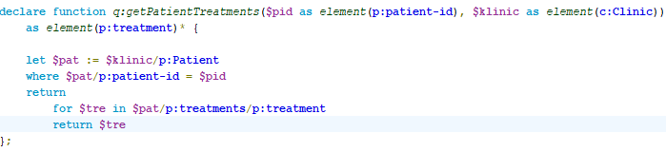

Here is the code for query 1

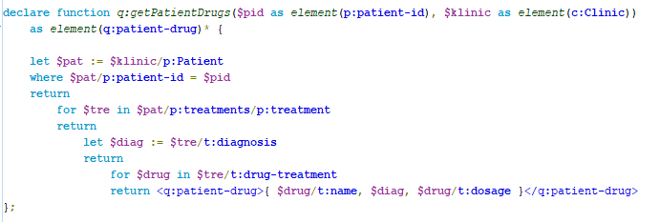

Here is the code for query 2, the diag variable is used to store the value and return it at its child level

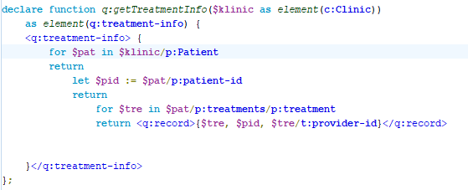

Here is the code for query 3

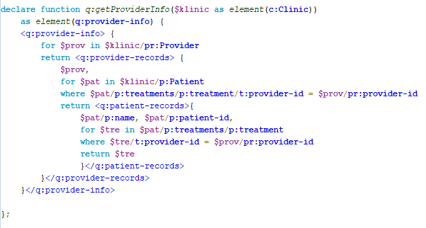

Query 4

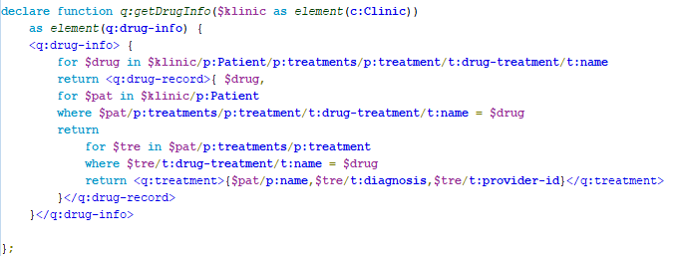

Query 5

The testing of the queries will be in the demonstration video. The project is written using Oxygen XML Developer.